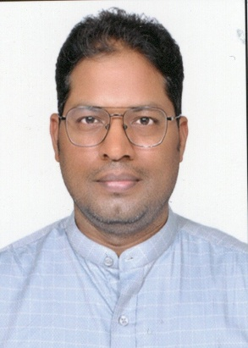

KRISHNA KANT VERMA
Mobile: 7081087149
Email: verma.kk1985@gmail.com
Address: Flat No. 1706, Block-S, Sargam Apartment, Kursi Road, Lucknow, Uttar Pradesh
Career Objective
To contribute effectively in the field of commerce, taxation, and academics by utilizing my knowledge, research aptitude, and professional experience while continuously striving for excellence and institutional growth.
Educational Qualifications
- Junior Research Fellowship (JRF) – 2014
- UGC-NET – 2012
- B.Ed – CCS University, Meerut (2007)
- M.Com – University of Allahabad (2006)
- B.Com – University of Lucknow (2004)
Professional Experience
Assistant Professor
Department of Commerce, University of Lucknow
(18 February 2026 – Present)
- Teaching undergraduate and postgraduate students
- Actively involved in academic research and curriculum development
- Mentoring and guiding students in academic projects

Divisional Accountant
Shakti Bhavan
03 August 2017 – 17 February 2026
- Managed financial records and accounting operations
- Ensured compliance with financial regulations and audit requirements
- Budget monitoring, reporting, and financial analysis

Professional Training / Certifications
- SAP (ERP) Training – Accenture
- Corporate Accounting – FICO Module (UPPCL)

Achievements
- Qualified UGC-NET (2012)
- Awarded Junior Research Fellowship (2014)
- Selected as Statistical officer in Commercial Tax (UPPSC, 2020)

Skills
- Accounting & Taxation Expertise
- Teaching & Academic Research
- Financial Analysis & Reporting
- MS Excel, MS Word
- Communication & Leadership Skills

Languages Known
- Hindi
- English

Personal Details
- Father’s Name: Late Lalla Ram Verma
Nationality: Indian
- Date: 05.04.2026
Place: Lucknow

