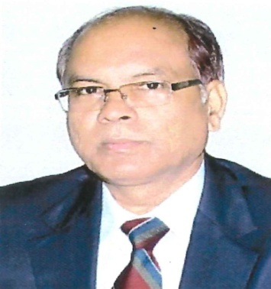

Professor MUNNA SINGH
Fellow-JSPS, JAPAN
Formerly Vice Chancellor, CSA University of Agriculture & Technology, Kanpur
Botany Department,University of Lucknow, Lucknow
e-mail: drmunnasingh@yahoo.com
Mob.# 9451766349

Synoptic View
Dr. Munna Singh PhD (Gold medallist by ICAR), Fellow–Japan Society for the Promotion of Science (JSPS), JAPAN, Formerly Vice Chancellor, Chandra Sekhar Azad University of Agriculture &Technolgy(CSAUA&T), Kanpur, working as Professor of Botany at University of Lucknow, Lucknow after serving GB Pant Univesity of Agriculture & Technology, PANTNAGAR (Uttarakhand) for nearly two decades, also as Professor & Head, Plant Physiology. Completed doctoral research from University of Lucknow in 1991 under the guidance of Dr. P.V. Sane, Fellow - National Academy of Sciences (FNA) former Director CSIR- NBRI, Lucknow. From 1998-2000, Prof. Singh underwent an international learning as Fellow-JSPS, JAPAN from Okayama University, Okayama, JAPAN for two years under Prof. Kimiyuki Satoh, the world fame plant biologist. Prof. Singh also carried out an advance study in modern biology viz., functional genomics of chloroplast biogenesis in pea crop plants at Turku University, Biocity, FINLAND in 2002 with Prof. Eva-Mari Aro, Fellow Finnish Academy of Sciences, Finland, another premier plant scientist of the world.

The Department of Science & Technology, Ministry of Science & Technology, Govt. of India awarded him BOYSCAST (better opportunity for young scientists in chosen areas of science & technology) Fellowship in 1998 to pursue the postdoctoral research at University of California, USA. Also being conferred a prestigious Jawahar Lal Nehru National Award with Gold-Medal for outstanding research work in agricultural sciences (Plant Physiology & Molecular Biology) by the President, Indian Council of Agricultural Research (ICAR), New Delhi, Govt. of India in 1995. Awarded Honorary Fellow for Indian Society of Biochemist in 2013. Elected Executive Councillor of Indian Academy of Social Sciences for 2014-15. Dewang Mehta Business School Award in 2014, also recipient of Uttar Pradesh Govt’s apex Saraswati Sammaan in 2014 for outstanding contribution in education.

Guided over 45 PhD-PG students, who have been awarded their degrees by GB Pant University of Agriculture & Technology, Pantnagar, and University of Lucknow. Completed nearly a dozen research projects & published over 90 research papers in national and international journals of high repute, which are cited in high ranking impactful Journals globally such as J.Biological Chemistry,USA; Nucleic Acid Research,USA; Plant Physiology,USA etc. Published two laboratory manuals, one each for UG & PG from GB Pant University, PANTNAGAR along with 07 advance books from Lambert Academic Publishing & Scholar’s Press, GERMANY. Paper published in Fluoride Research Report 46:83-89, 2013 rated EXCELLENT by Prof. Bruce Spittle, Managing Editor Fluoride, New Zealand. Paper published in Z. Naturforsch 47C: 63-68, 1991 (Germany) rated AMAZING & ONE OF THE FIRST FINDINGS by Dr. ALEX, USA in 2019. Delivered Over 30 invited lectures in national & international meets in India and abroad, also visited Japan, Finland and Germany.

